**Practical 5: Modelling – Data Flow Diagram and Control Flow Diagram**

**Objective:**

To model the data flow and control flow of the **Agriculture Management System** using **DFD** and **CFD** techniques.

**Tools Used:**

* Draw.io / Lucidchart / Microsoft Visio / Paper & Pencil
* Any text editor for documentation (MS Word, Google Docs, etc.)

**Theory:**

**Data Flow Diagram (DFD):**

A Data Flow Diagram represents the **flow of data** within a system. It shows how data is input, processed, stored, and output through **processes**, **data stores**, **external entities**, and **data flows**.

* **External Entity:** Source/destination of data (e.g., Farmer, Admin)
* **Process:** Operation on data (e.g., Manage Crops, Schedule Irrigation)
* **Data Store:** Database or file storing information (e.g., Crop Info DB)
* **Data Flow:** Movement of data between the above components

**Control Flow Diagram (CFD):**

A Control Flow Diagram represents the **control logic** of processes, showing the **order of execution**, **decisions**, and **branches** using conditions and control statements.

**Agriculture Management System – Overview:**

The system helps farmers and administrators manage:

* Crop details
* Soil and weather info
* Irrigation schedules
* Equipment management
* Crop selling/marketing
* Fertilizer and pesticide tracking

**Data Flow Diagram (DFD)**

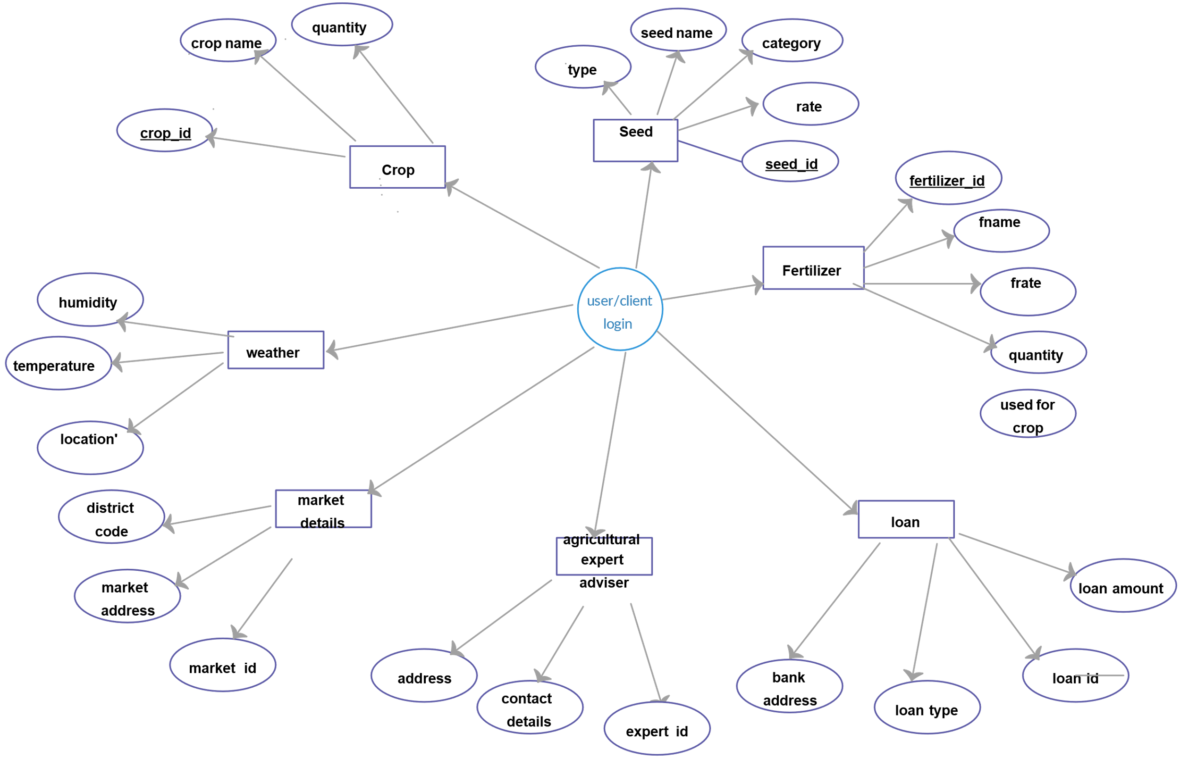

**Conclusion:**

In this practical, we analyzed and modeled the **Agriculture Management System** using **Data Flow Diagrams** and **Control Flow Diagrams**. The DFD helped visualize **data movement**, while the CFD described the **logic and flow of operations** such as crop management and irrigation scheduling. This modeling helps in better system understanding, planning, and implementation.